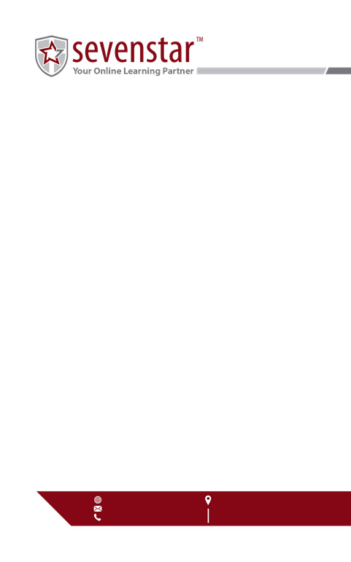

Sevenstar

645 South Custer RD, STE 208

Allen, Texas 75013

www.sevenstar.org

info@sevenstar.org

513.612.1029

Letter text